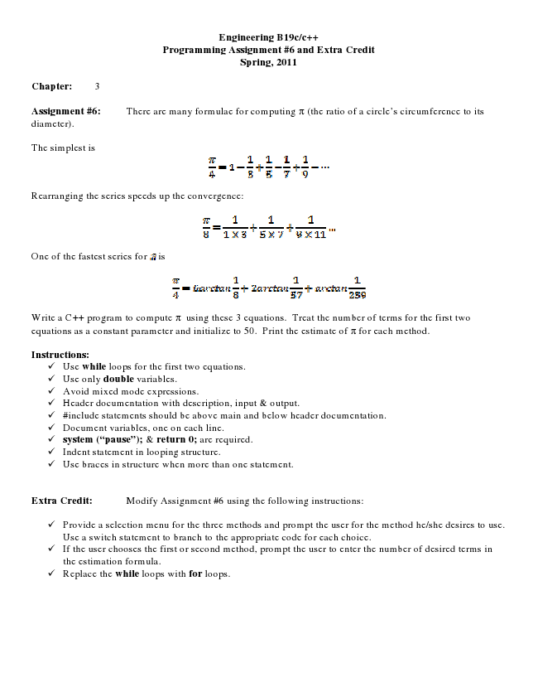

**Engineering B19c/c++ Programming Assignment #6 and Extra Credit Spring, 2011**

**Chapter: 3**

Assignment #6: There are many formulae for computing π (the ratio of a circle’s circumference to its diameter).

The simplest is

Rearranging the series speeds up the convergence:

One of the fastest series for

Write a C++ program to compute π using these 3 equations. Treat the number of terms for the first two equations as a constant parameter and initialize to 50. Print the estimate of π for each method.

**Instructions:**

✓ Use while loops for the first two equations. ✓ Use only double variables. ✓ Avoid mixed mode expressions. ✓ Header documentation with description, input & output. ✓ #include statements should be above main and below header documentation. ✓ Document variables, one on each line. ✓ system (“pause”); & return 0; are required. ✓ Indent statement in looping structure. ✓ Use braces in structure when more than one statement.

Extra Credit: Modify Assignment #6 using the following instructions:

✓ Provide a selection menu for the three methods and prompt the user for the method he/she desires to use.

Use a switch statement to branch to the appropriate code for each choice. ✓ If the user chooses the first or second method, prompt the user to enter the number of desired terms in

the estimation formula. ✓ Replace the while loops with for loops.

is